**Introduction to .NET Framework**

The .NET Framework is a software development framework developed by Microsoft that provides a runtime environment and a set of libraries and tools for building and running applications on Windows operating systems.

**Common Language Runtime (CLR):** At the core of the .NET Framework is the CLR, which provides various services, including memory management, exception handling, and security. It also enables interoperability between different programming languages targeting the .NET platform.

**Base Class Library (BCL):** The BCL is a collection of classes and functions that provide a wide range of functionality for developing applications. It includes classes for working with strings, collections, file I/O, networking, and much more.

**Languages:** The .NET Framework supports multiple programming languages, including C#, Visual Basic .NET, and F#.

**ASP.NET:** For web development, ASP.NET is a key component of the .NET Framework. It provides a robust framework for building dynamic web applications, web services, and APIs using languages like C# or Visual Basic.

**Windows Presentation Foundation (WPF):** WPF is a graphical subsystem for rendering user interfaces in Windows-based applications. It provides a rich set of controls, layout options, and data binding capabilities for creating visually appealing desktop applications.

**Windows Communication Foundation (WCF):** WCF is a framework for building distributed and interoperable applications. It enables developers to create services that can communicate with each other using various protocols and message formats.

**Entity Framework:** Entity Framework is an object-relational mapping (ORM) framework that simplifies data access in .NET applications. It allows developers to work with relational databases using strongly-typed .NET objects, eliminating the need for much of the tedious data access code.

**Advantages of .NET Framework:**

**Multi-language support:** The .NET Framework supports a variety of programming languages, including C#, F#, and Visual Basic, which allows developers to choose the language that best fits their needs and expertise.

**Cross-platform compatibility:** The .NET Framework can run on multiple operating systems, including Windows, Linux, and macOS, which provides flexibility in developing and deploying applications.

**Large community:** The .NET Framework has a large and active community of developers who have created a wide range of resources, including libraries, tools, and documentation.

**Security:** The .NET Framework includes a variety of security features, such as code access security and digital signatures, which can help protect applications from malicious attacks.

**Productivity:** The .NET Framework includes a large set of pre-built libraries and tools that can help developers save time and improve productivity.

**Disadvantages of .NET Framework:**

**Windows dependency:** Although the .NET Framework can run on multiple operating systems, it was originally designed for use on Windows operating systems, which means that it may not be the best choice for cross-platform applications.

**Large footprint:** The .NET Framework has a large installation footprint, which can make it difficult to deploy applications on systems with limited storage or bandwidth.

**Licensing:** Some versions of the .NET Framework require a license, which can add to the cost of developing and deploying applications.

**Performance:** While the .NET Framework provides good performance for most applications, it may not be the best choice for high-performance applications that require low-level access to hardware or complex algorithms.

**Learning curve:** Although the .NET Framework is designed to be easy to use, it still has a learning curve, especially for developers who are new to the platform or to object-oriented programming in general.

The .NET Framework’s basic architecture consists:

**Common Language Runtime (CLR):**

* The CLR is the heart of the .NET architecture. It provides a runtime environment for executing managed code.
* It manages memory, handles exceptions, performs garbage collection, and provides various services such as security and threading.
* The CLR ensures that .NET applications are platform-independent by compiling code into an intermediate language (IL) that is executed by the CLR's just-in-time (JIT) compiler.

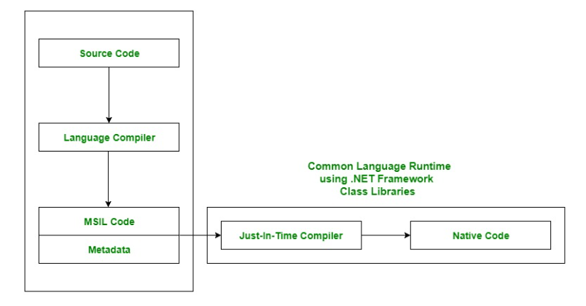

**Main components of CLR:**

-Common Language Specification (CLS):

it provides Language Interoperability. Language Interoperability means providing execution support to other programming languages also in .NET framework.

Language Interoperability can be achieved in two ways :

Managed Code: The MSIL code which is managed by the CLR is known as the Managed Code.

Unmanaged Code: Before .NET development, programming languages like.COM Components & Win32 API do not generate the MSIL code. So these are not managed by CLR rather managed by Operating System.

-Common Type System (CTS):

CTS is responsible for understanding all the data type systems of .NET programming languages and converting them into CLR understandable format which will be a common format.

There are 2 Types of CTS-

Value Types: Value Types will store the value directly into the memory location. These types work with stack mechanisms only. CLR allows memory for these at Compile Time.

Reference Types: Reference Types will contain a memory address of value because the reference types won’t store the variable value directly in memory. These types work with Heap mechanism. CLR allot memory for these at Runtime.

-Garbage Collector:

It is used to provide the Automatic Memory Management feature. If there was no garbage collector, programmers would have to write the memory management codes which will be a kind of overhead on programmers.

-JIT(Just In Time Compiler):

It is responsible for converting the CIL(Common Intermediate Language) into machine code or native code using the Common Language Runtime environment.

-Exception Handling:

The CLR provides a robust mechanism for handling exceptions in .NET applications.

It allows developers to write code to catch and handle exceptions, ensuring graceful error handling and recovery.

Exception handling in the CLR includes support for structured exception handling (try-catch-finally blocks), custom exception types, and exception filters.

-Security:

Security is a fundamental aspect of the CLR, ensuring that .NET applications run in a safe and secure environment.

It enforces various security measures, such as code access security (CAS), role-based security, and code signing, to prevent unauthorized access and malicious code execution.

The CLR also provides support for sandboxing, allowing applications to run with restricted permissions in controlled environments.

-Execution Engine:

The Execution Engine is responsible for loading, verifying, and executing managed code within the CLR.

It manages the execution flow of .NET applications, including method invocation, exception handling, and memory management.

The Execution Engine interacts with other components of the CLR, such as the JIT compiler and the Garbage Collector, to ensure efficient execution of code.